Jayd Pather

Full stack

developer

self-motivated
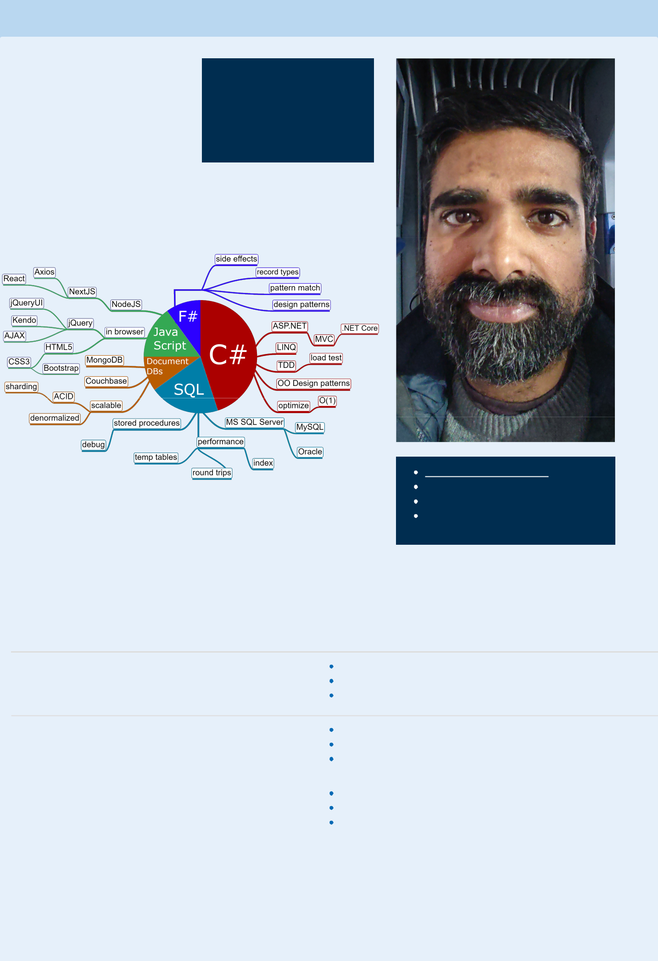

explains coding to

anyone

writes simple code

rebelsoftware.nl/demoapps

jaydpather@gmail.com

312 826 3213

4555 North Malden Street APT 211,

Chicago, IL 60640

Work History

Employer Experience Accomplishments

Phillips Van developed an application for wholesale

Heusen clothing sales

2018 - 2020

trained junior developers

fixed a performance issue involving excess garbage collection debugged stored procedures

IQVIA | fixed bugs in an app used by | wrote SQL scripts to correct corrupted data saved by the app
2017 - 2018 | pharmaceutical companies for government | diagnosed and fixed bugs
 | reporting | improved the support process with reusable scripts
Sovos | extended the VATWare app by adding | refactored code to use dependency injection
Compliance | support for German tax reporting | added missing unit tests
2016 - 2017 |  | found and reported bugs

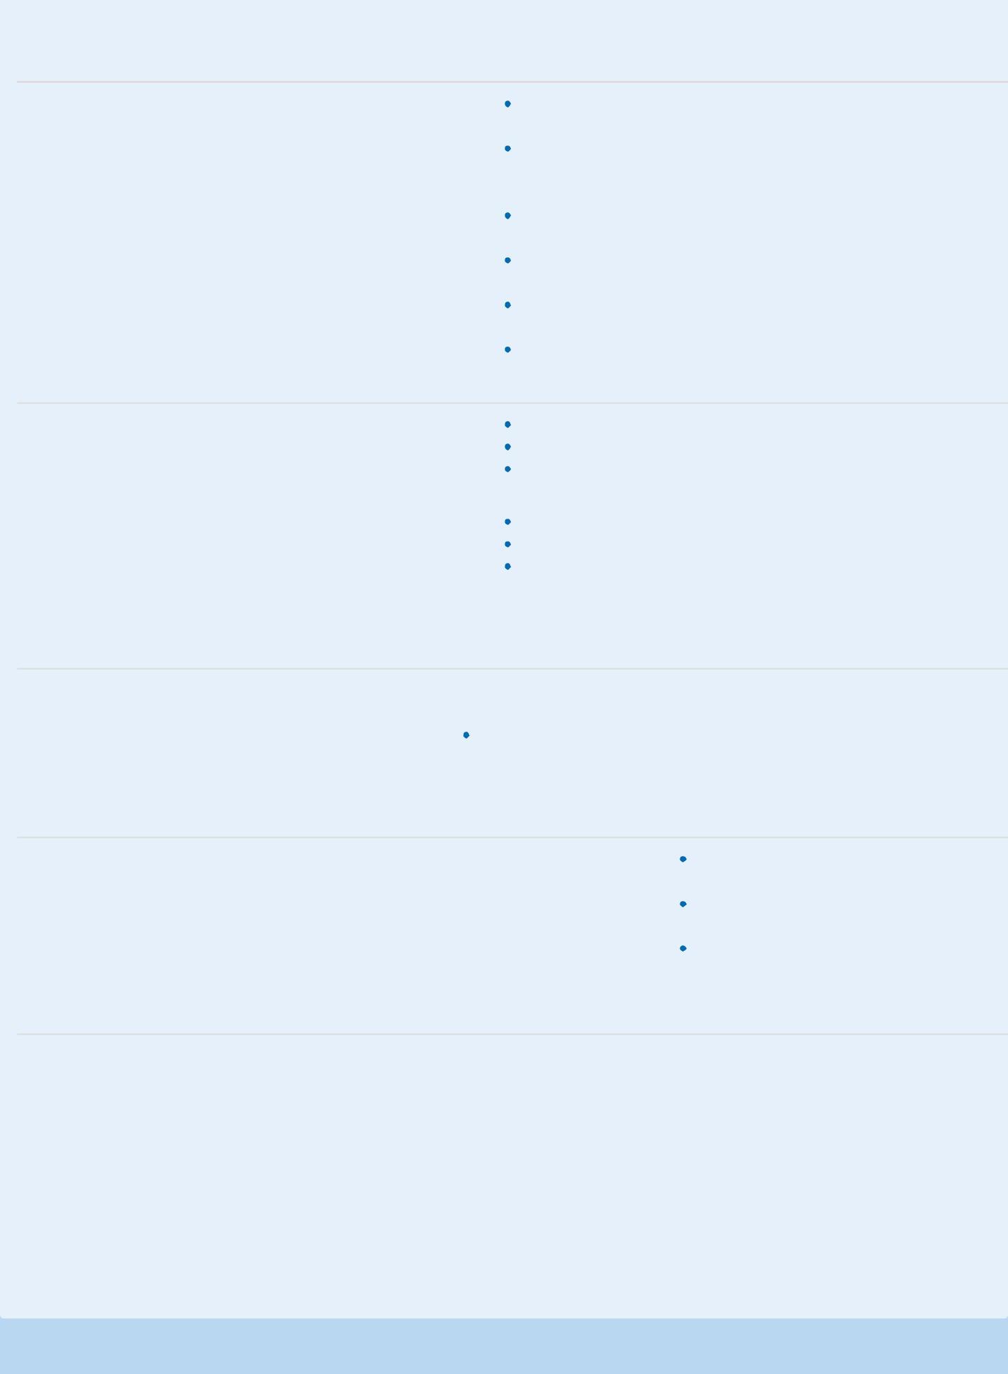
Employer Experience Accomplishments

Robert Half worked on temporary assignments for

Technology various clients, usually internal business

2011 - 2016 apps

Sovos Compliance - developed a scalable tax reporting app with microservices, TDD, and agile.

Lifeworks Services, Inc. - created SSRS reports, fixed SQL performance issues, fixed a concurrency bug that had caused $30,000 in losses

Stillwater Express Solutions, Inc. - learned ASP.NET MVC, Kendo, Entity Framework. Met with clients to help design the app.
RCRI, Inc. - fixed resource leaks, normalized DB schema, implemented 3-tier architecture

ProVation Medical - used the strategy pattern to remove duplicate code, improved performance by 26%

UnitedHealth Group - consolidated duplicate code, designed database schemas, helped other developers with bugs

BillboardPlanet | developed an app for booking ads on | developed a video player app for digital billboards
2009 - 2011 | billboards | implemented 3-tier architecture
 |  | helped other developers
Propelware | developed an app for syncing data to | data sources include CSV, XML, SQL
2008 - 2009 | QuickBooks | used the flyweight pattern for code reuse
 |  | used multithreading to update the UI while importing data

Education

University of Bachelor of Science, Computer emphasis: systems programming (compilers, operating systems, assembly

Minnesota Science programming)

GPA: 3.0 / 4.0

Side Projects

Rebel | designed, developed, and released an ad-free game for Android:
Software | Asteroid Field Navigation
2016 -
present

used the strategy pattern to simplify the code architecture

decoupled my code from the Unity game engine

crowdsourced a beginner programmer

All Skills

Languages | C#, F#, JavaScript, HTML5, CSS3, Java, Python, PHP, LISP, SML, C, C++, MIPS assembly
Databases | Microsoft SQL Server, Oracle, MySql, MongoDB, Couchbase
Source Control | Git, GitHub, SourceTree, VSTS, Tortoise SVN
Operating | Windows, Linux
Systems
APIs | .NET Core, ASP.NET MVC, LINQ, NUnit, NodeJS, NextJS, Axios, React, Bootstrap, Unity, Kendo, JQuery, JQuery UI,
 | Telerik, DevExpress

